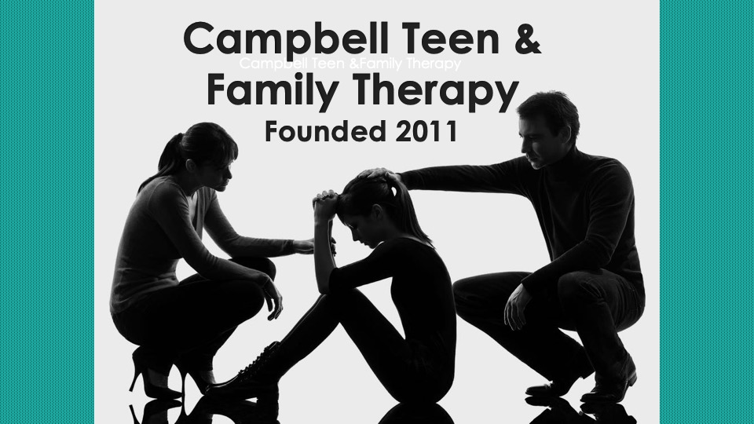

Consent for Telehealth Care

I understand the risks and benefits of telehealth and agree to have a telehealth session with my clinician.

X_____________________________________________________________

www.campbellteenfamilytherapy.com

